Biology 252/254 Exam 3, Fall 2005 Rick Kesseli

Your Name
Show your work clearly. You may be eligible for partial credit even if your answer is wrong.

1. (15points) How are Hfr lines formed (describe important sequences involved)? Why are they called high frequency recombination, yet they fail to make the recipient cell Hfr or F+? State the major events that need to occur for this high frequency recombination to occur.

2. (14 points) A. Name seven proteins or enzymes (there are more than seven) involved in DNA replication in prokaryotes. B. Describe clearly and briefly the function of each of these components. C. When during the cell cycle does this process generally occur?

3. (14 points) For the Messelson and Stahl experiment below, what would have been the results if replication had been conservative? What results did they get indicating semi-conservative? Use the centrifuge tubes drawn below to describe your expected results. Label appropriately.
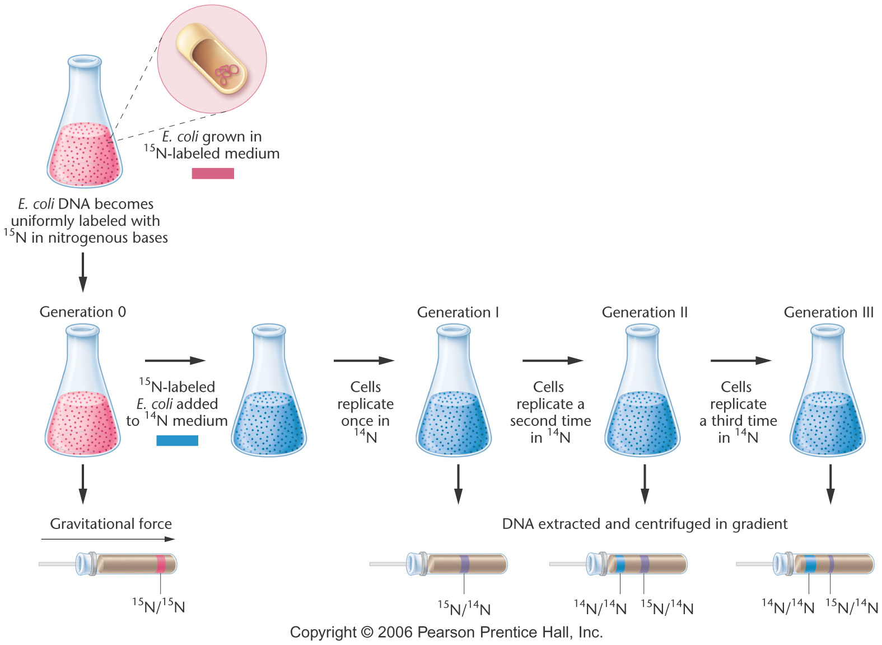
Conservative
Semi-Conservative

4) (12 points) At one point, Watson proposed a model in which like bases paired with like, that is C-C, T-T, G-G and A-A. Give two reasons why this model fails to explain the data that was available at the time.

5. (14 pts) Draw a replication origin in E. coli with newly synthesized DNA. Label polarity of ALL template and growing (newly synthesized) strands, show direction of synthesis on all growing strands and identify leading and lagging strands in both forks. Your picture must show the position of at least four primers.

6. (15 points) Shown below is a piece of DNA from the middle of a much longer piece. CIRCLE (be precise sloppy circles including incorrect or partial molecules will be marked wrong) and identify one phosphate molecule, one deoxyribose sugar, and ALL the different nitrogeneous bases (these must be labeled with the appropriate base). Also, number the carbons of one sugar and label the polarity of the molecule (the 3’ and 5’ orientation). Finally, if the right side of the molecule was the template strand, in what direction would synthesis be proceeding (draw an arrow)?

7. (14 points) What special challenges are faced during the complete replication of a full chromosome in eukaryotes? That is, what characteristics of eukaryotic chromosomes make their replication more complex than replication in prokaryotes, and how are the complexities solved? Again, be brief and to the point; I am only looking for a couple of significant differences each of which needs a sentence or two of explanation.

8. (14 points) Surprisingly, when scientists were performing reassociation experiments some DNA in mammals snapped back together faster and some slower than that of E.coli. What had they expected and explain why was it different? Describe the nature and function and give examples of sequences found in the two different classes of mammalian DNA.

Some organisms, for example Amoeba dubia, have an enormous amount of DNA and yet seem relatively simple.
All repetitive DNA is junk. Give evidence that both supports and refutes this sentence.

